# Question 1: Long-term AI Future Vision

**In your view, what is the ultimate, long-term future of AI in the festival and live events industry over the next decade? What will be the most significant, visible difference between a non-AI-driven event and an AI-optimized event for the average attendee?**

# The Future of AI at Festivals: What You’re Actually Preparing For

**Learning Objectives:** - Describe the transformation timeline (2025-2035) and what changes for attendees - Identify barriers preventing implementation and patterns that drive success - Evaluate vendor claims against documented outcomes - Distinguish hype from realistic expectations based on evidence

Here’s the uncomfortable truth: by 2035, you’ll work in an industry where 95% of major festivals use AI for everything from crowd control to personalized schedules. But here’s the catch—over 80% of organizations deploying AI today report **zero significant impact** on their bottom line.

The technology works. The implementation usually doesn’t.

What’s the actual future you’re preparing for? Not the vendor pitch, but what’s likely based on documented deployments? The answer splits into two parts: what changes for attendees, and how the transformation unfolds over the next decade. Both are more complicated than the hype suggests.

## What Your Attendees Will Experience

Picture a festival-goer at a traditional event in 2025. They’re browsing lineups on Reddit, checking artist schedules, printing maps, hoping not to lose their friends in the crowd. It works. It’s worked for decades.

Now consider that same attendee at an AI-optimized festival in 2035—one you might be managing. Before they bought their ticket, an algorithm analyzed their Spotify history and recommended this festival over three others they’d never heard of. When they arrive, their phone guides them through the least-crowded entrance with real-time wait times. Their personalized schedule auto-resolved conflicts they didn’t notice, suggesting a lesser-known artist who—based on listening patterns—they’ll probably love. When crowd density reaches dangerous levels near the main stage, your AI system spotted it 10 minutes early and redirected foot traffic before anyone got hurt.

That’s the operational difference you’ll implement. Not sentient robots or holographic performers. Just smarter logistics, better recommendations, proactive safety, and personalized experiences at scale. The festival still feels like a festival—attendees discover music, get lost, have unexpected moments. The AI just handles operational complexity they never wanted to think about anyway.

But here’s what’s already happening: **40-41% of ticket sales today come through AI recommendations** on platforms like DICE. Your attendees are choosing festivals via algorithms right now. They just don’t notice because good AI feels invisible.

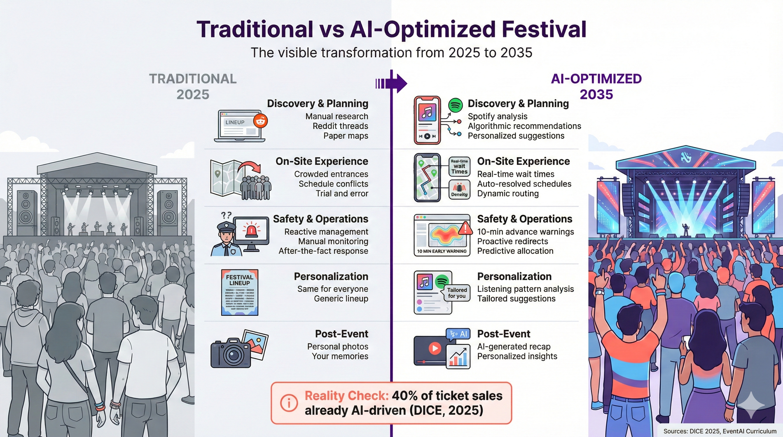

Traditional vs AI-Optimized Festival Experience showing the visible differences between 2025 baseline and 2035 AI-optimized experience

*Figure 1: Traditional vs AI-Optimized Festival Experience (2025-2035)*

## The Three-Phase Transformation

The shift won’t happen overnight. Based on current adoption rates, regulatory frameworks, and documented deployments, we’re looking at three distinct phases.

### Phase 1: Foundation Building (2025-2028)

Right now, 47% of event organizers use some form of AI. That climbs to 60-70% for major festivals by 2028, driven by three forces.

**Regulation got real.** The EU AI Act took effect February 2, 2025, with fines up to **€35 million or 7% of global revenue** for violations. Real-time facial recognition? Banned for private organizers. Crowd monitoring without biometric ID? Allowed if you’re transparent. Paris 2024 Olympics demonstrated this works: AI surveillance across 35 venues, zero facial recognition for GDPR compliance, officials declared success. The regulatory uncertainty that paralyzed decision-making is resolving.

**Infrastructure matured.** You can’t run real-time AI at a muddy outdoor festival without network capacity. 5G changed that. Verizon demonstrated sub-100ms latency for crowd surge detection in 2024. Edge computing lets you process data locally instead of sending everything to distant servers. Suddenly, AI that seemed impossible becomes feasible.

**Vendor consolidation cleaned up the mess.** When Fever acquired DICE in June 2025, it signaled market maturation. Festival organizers no longer stitch together point solutions from a dozen startups. Integrated platforms handle ticketing, recommendations, and analytics in one system.

But small festivals lag dramatically. While major festivals hit 60-70% adoption by 2028, small venues (under 5,000 attendees) stay at 25-35%. The gap isn’t about technology access—it’s about data volume. AI needs training data. A festival running once a year with 3,000 attendees doesn’t generate enough signal for accurate predictions.

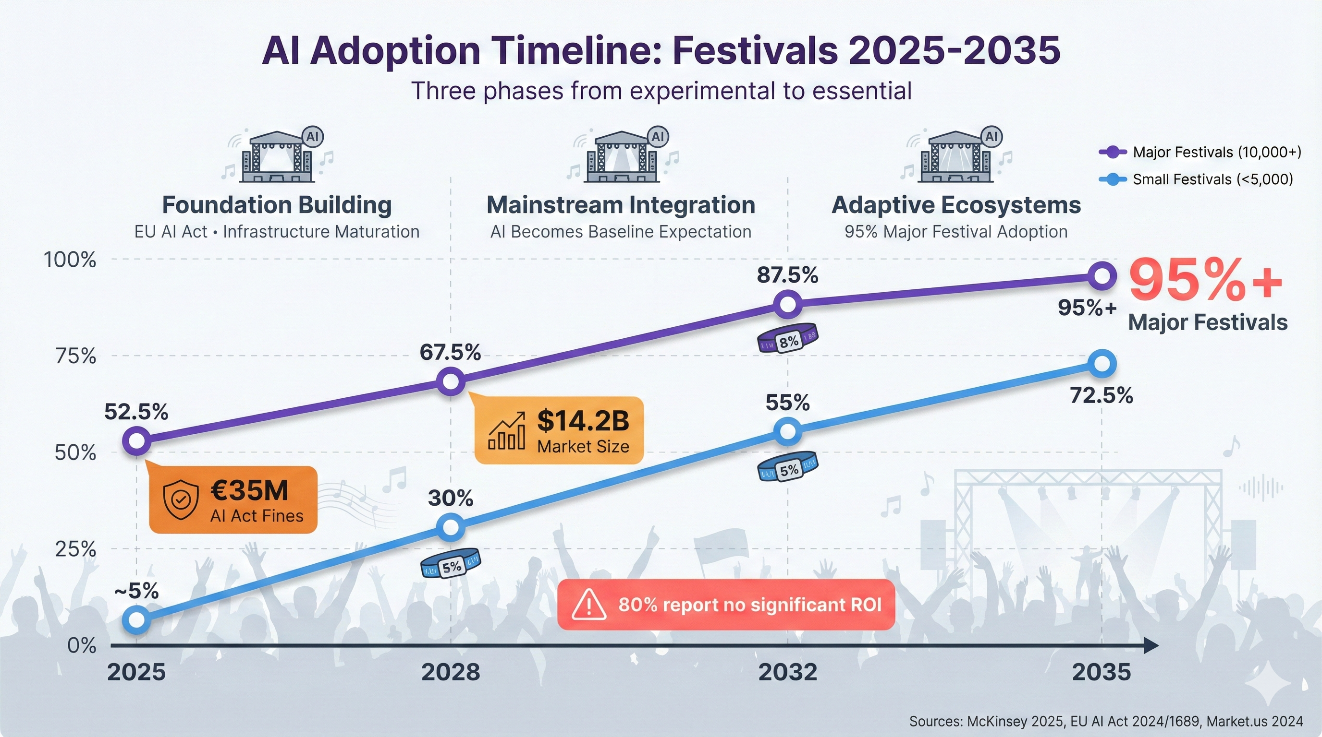

AI Adoption Timeline showing three phases of festival AI evolution from 2025-2035

*Figure 2: AI Adoption Timeline (2025-2035) - Reality check: 80% of organizations report no significant ROI despite massive investment increases.*

### Phase 2: Mainstream Integration (2028-2032)

Around 2030, AI stops being a feature and becomes baseline expectation. This mirrors WiFi in the 2010s—first a luxury, then non-negotiable. By 2032, expect 85-90% of major festivals to integrate multiple AI systems, not just one.

**Cross-festival identity emerges.** Think airline frequent flyer programs: your preferences from Coachella inform recommendations at Glastonbury, if you opt in. The data follows you across festivals. Privacy regulations (GDPR, CCPA) require explicit consent and portability, but the infrastructure exists.

**Generative AI for content becomes standard.** teamLab’s AI-responsive installations where visuals evolve based on crowd movement, Tomorrowland’s AI-generated music with 180 track variations—by 2030, this gets affordable enough for smaller festivals. The events you manage could become adaptive, responding to crowd energy in real-time.

**Predictive operations deliver measurable ROI.** Early adopters using AI for demand forecasting, staffing, and inventory management document 10-15% margin improvements. That competitive pressure forces others to follow. When your competitors reduce food waste by 12% and save $200K in staff optimization, staying traditional becomes harder to justify.

Attendee expectations shift here too. Gen Z and Gen Alpha grew up with algorithmic curation—Spotify, Netflix, TikTok. They expect festivals to work the same way. Real-time wait times, personalized itineraries, dynamic scheduling aren’t novelties; they’re the minimum acceptable experience.

Small festivals reach 50-60% adoption, but the 20-30 percentage point gap with major festivals persists. Economics don’t change—AI still favors scale.

### Phase 3: Adaptive Ecosystems (2032-2035)

By 2035, the cutting edge looks different. We’re talking festivals as adaptive ecosystems where AI orchestrates real-time adjustments at scales humans can’t process. You as festival director still control creative and strategic decisions. AI doesn’t replace curation. It handles operational optimization that would overwhelm any human team.

Picture yourself in this role: it’s Saturday evening, crowd density analysis shows 80% of attendees migrating toward the main stage. Your AI system recommends activating overflow areas, suggests triggering alternative entertainment in underattended zones, proposes a subtle schedule adjustment to spread the load. You review on your mobile dashboard and approve. Three minutes instead of three hours of emergency meetings.

Weather patterns change? Your AI integrates forecasts with historical attendance data. Rain in two hours? The system pre-positions ponchos, adjusts food inventory toward hot items, deploys extra staff to pathways that’ll get muddy, all based on learned patterns from previous rain events. You get a plan to approve, not a crisis to manage.

The crucial part: this works through anonymous aggregate data, not individual tracking. The system detects “500 people stationary for 15 minutes in sector C” without knowing who those people are. Privacy stays protected. Operational intelligence stays sharp.

95% of major festivals reach this capability by 2035. Small festivals hit 70-75%, maintaining that persistent 20-25% gap.

But this is speculative. We’re extrapolating from current trends, not documenting existing deployments. Organizational inertia, creative control concerns, technical complexity—any could slow adoption below projections.

## Why AI Fails Most of the Time

McKinsey’s 2025 research is damning: over 80% of organizations report no significant bottom-line impact from AI investments. Only 6% achieve “high performer” status. Only 1% consider their deployment “mature.”

Meanwhile, AI investment skyrocketed from $11.5 billion in 2024 to $37 billion in 2025—a 3.2x increase—despite these terrible results. We’re in a hype cycle where everyone’s buying lottery tickets, and almost nobody’s winning.

Five barriers explain why.

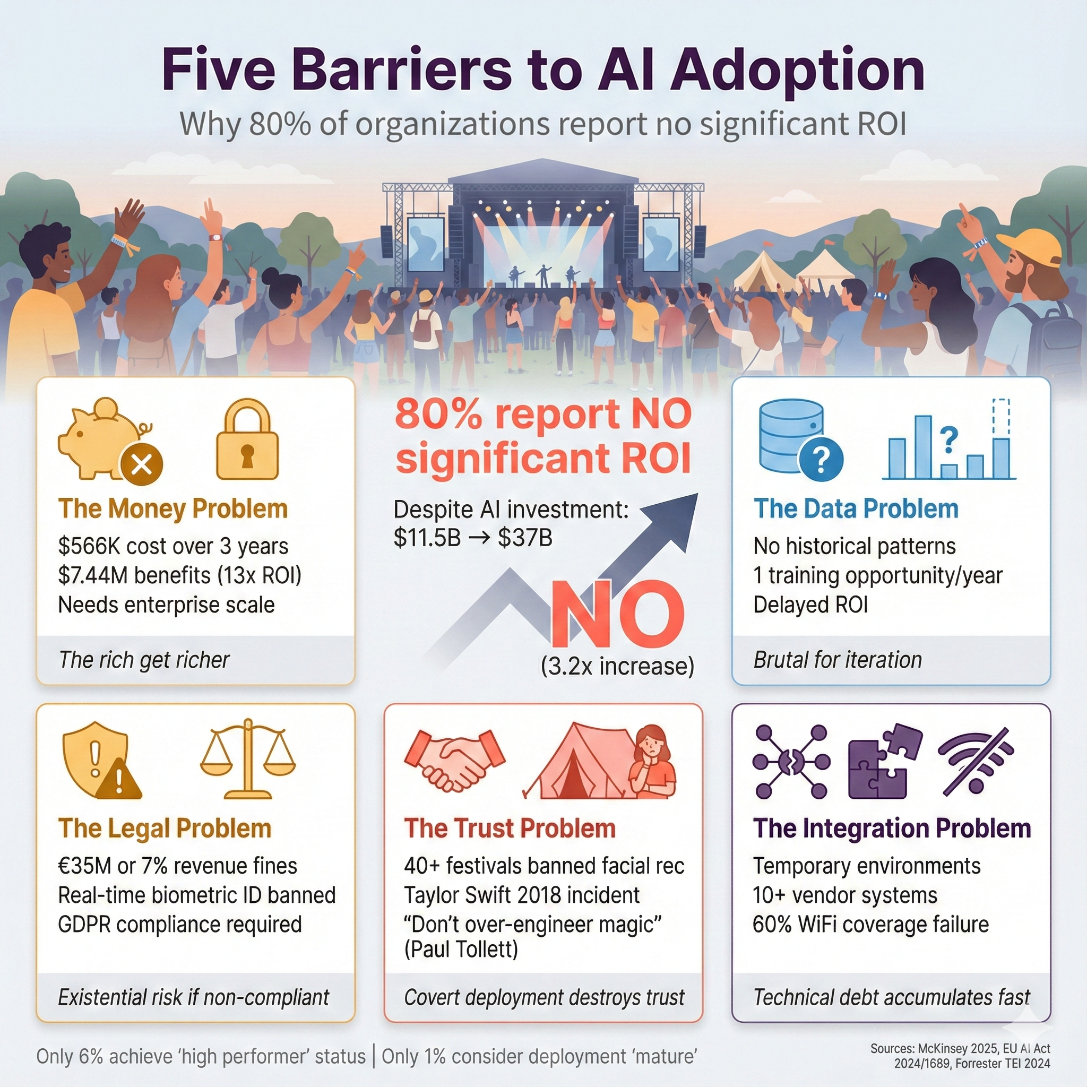

Five Barriers to AI Adoption

*Figure 3: Five Barriers to AI Adoption*

**The Money Problem**: Legion WFM workforce optimization costs $566,000 over three years. It generates $7.44 million in benefits for enterprise operations—a 13x return. But you need enterprise scale to hit those numbers. Small festivals can’t afford the upfront investment and don’t process enough transactions to train accurate models.

**The Data Problem**: AI needs training data. If you’re deploying crowd prediction for the first time, you have no historical patterns. Transfer learning helps—start with models trained elsewhere, then fine-tune. But it’s complicated and delays ROI. Annual festivals get one training opportunity per year. That’s brutal for iterative improvement.

**The Legal Problem**: EU AI Act fines reach €35 million or 7% of global turnover, whichever’s higher. That’s existential risk for non-compliant systems. Real-time biometric identification? Banned. Post-event biometric analysis? High-risk, requiring conformity assessments and documentation. GDPR adds another layer: biometric data requires explicit informed consent. Entrance with a sign saying “AI surveillance in use” doesn’t count.

**The Integration Problem**: Festivals are temporary environments. Limited network infrastructure. Distributed power from generators. Harsh conditions—dust, mud, rain, heat. Multi-vendor ecosystems with 10+ systems that need to talk to each other. One festival CTO told us anonymously: “We bought AI crowd prediction requiring WiFi triangulation. Our WiFi coverage was 60%. The AI was blind in 40% of the venue. We paid for a year, got zero value.”

**The Trust Problem**: 40+ major festivals pledged no facial recognition after civil rights campaigns in 2019. The Taylor Swift 2018 Rose Bowl incident—where 60,000 attendees got secretly scanned via kiosks—generated backlash that kills technology adoption regardless of capability. Covert deployment destroys trust. And there’s creative tension too: Coachella founder Paul Tollett said in 2024, “Part of the festival experience is getting lost, stumbling into a tent you didn’t plan to visit, having your mind blown. We have to be careful AI doesn’t over-engineer that magic.”

## What Actually Works

When AI does work at festivals, it follows predictable patterns. Four factors separate success from expensive failure.

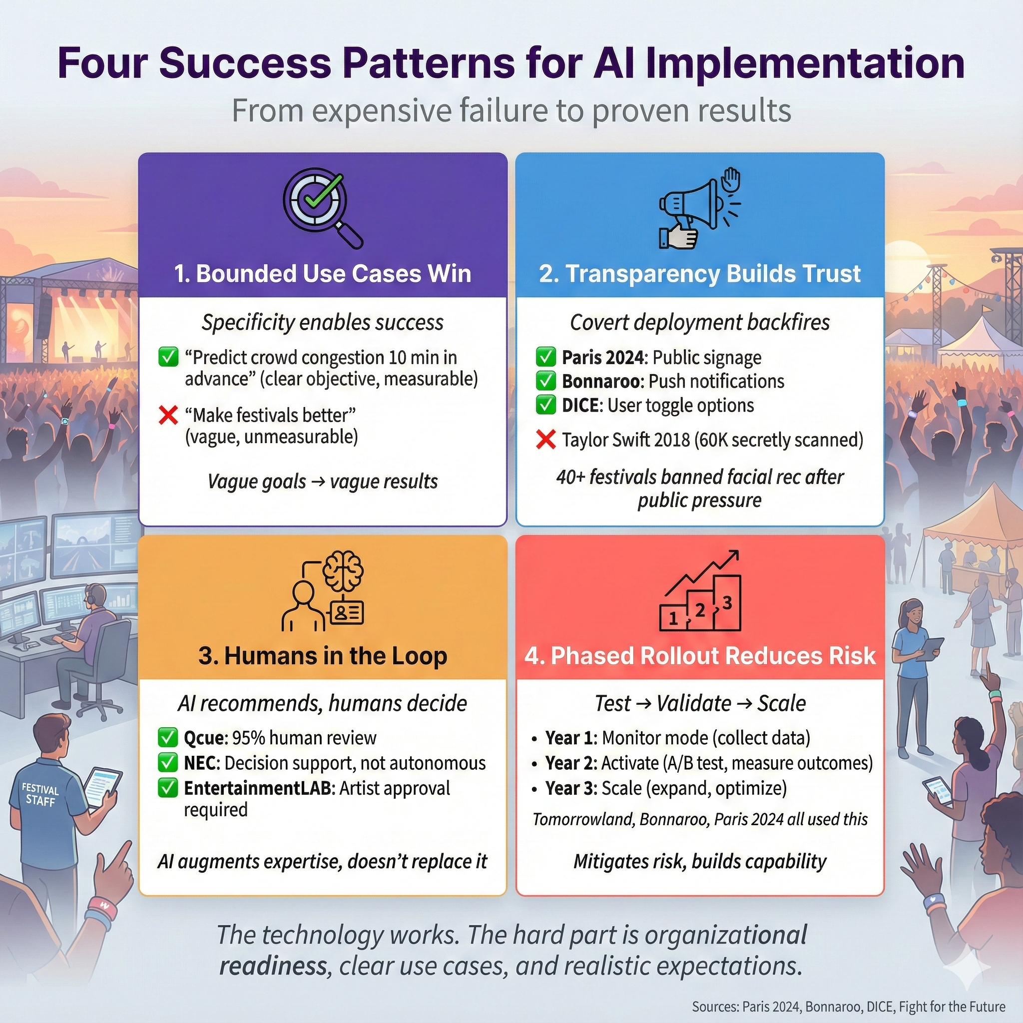

Four Success Patterns

*Figure 4: Four Success Patterns for AI Deployment*

**Bounded use cases win**. “Predict crowd congestion 10 minutes in advance and alert control room operators” succeeds. “Deploy AI to make festivals better” fails. Specificity enables measurement. You can iterate. You can train staff. You can prove ROI.

**Transparency builds trust**. Paris 2024 announced AI surveillance publicly, posted signage, published legal authorization. Bonnaroo sent notifications explaining iBeacon functionality. DICE lets users toggle off recommendations. The 40+ festivals that banned facial recognition show that covert deployment backfires. Trust is foundational, not optional.

**Humans stay in the loop**. Qcue’s dynamic pricing keeps 95% of price changes human-reviewed. NEC’s crowd prediction provides decision support, not autonomous action. AI excels at processing signals humans can’t integrate—thousands of data points updating every second—but it lacks context, creativity, and ethical judgment. The best systems augment human expertise, not replace it.

**Phased rollout reduces risk**. Year one: deploy in monitoring mode, collect data, build staff literacy. Year two: activate predictions, A/B test against traditional methods, measure outcomes. Year three: scale what works, kill what doesn’t. Tomorrowland, Bonnaroo, Paris 2024—the success stories all followed versions of this pattern.

None of this is revolutionary. It’s boring implementation discipline. But that’s the point. The technology works. The hard part is organizational readiness, clear use cases, and realistic expectations.

## The Bottom Line

So what’s the actual future? Here’s what the evidence supports, sorted by confidence level.

**Near certainty (80%+ confidence)**: Ticketing and marketing AI hits 90%+ adoption by 2030. Crowd monitoring becomes standard at major festivals by 2028, driven by regulatory pressure and documented safety value—Smukfest’s 10-15 minute advance warnings prevented crushes at 45,000+ attendance. Dynamic pricing replaces static tiers for 70%+ of festivals by 2032 because revenue gains are provable.

**Probable (60-80% confidence)**: Personalized itineraries become expected by 2030, following broader consumer tech trends from Spotify and Netflix. Predictive operations for staffing and inventory deliver 10-15% margin improvements, creating competitive pressure that spreads adoption. Regulatory frameworks stabilize by 2027 as EU AI Act sets precedent.

**Speculative (below 60% confidence)**: Generative AI content going mainstream faces creative resistance and copyright uncertainty. Small festival adoption exceeding 75% by 2035 seems unlikely given persistent economic barriers. Full integration where AI orchestrates real-time program changes runs into organizational inertia and creative control concerns that may prove harder to overcome than forecasts suggest.

The most important pattern: **AI is a tool, not a strategy**. When you deploy AI as a festival professional, focus on solving specific problems, measuring outcomes rigorously, maintaining human oversight, and prioritizing attendee trust. That’s how you join the 6% of high performers. Chasing innovation for its own sake puts you in the 80%+ reporting no significant impact.

As students entering the festival industry, critical AI literacy will be essential for your career. You’ll need to evaluate vendor claims, assess evidence, understand technical and organizational limitations, and advocate for responsible deployment. These analytical skills matter as much as event logistics and creative programming.

That’s the future you’re preparing for: not utopian, not dystopian, just complicated. AI will transform the festivals you work for, but transformation isn’t automatic. It requires hard implementation work, clear-eyed assessment of barriers, and realistic expectations about what technology can and can’t deliver. The organizations that figure this out will thrive. The ones chasing hype will wonder why they’re in the 80% with nothing to show for their investment.

**Sources:**

* [DICE Partners Page](https://dice.fm/partners/ticketing/live) - 40-41% AI-driven sales
* [EU AI Act Regulation 2024/1689](https://artificialintelligenceact.eu/)
* [Paris Olympics AI Surveillance - Milipol](https://news.milipol.com/olympics-ai-surveillance/)
* [Market.us AI in Event Management Report 2024](https://market.us/report/ai-in-event-management-market/) - $1.8B to $14.2B projection, 22.9% CAGR
* [Event Industry News AI Report 2025](https://www.eventindustrynews.com/guides/event-industry-news-launches-groundbreaking-ai-report-2025-in-partnership-with-eventmobi) - 47% current adoption
* [Forrester TEI Study - Legion WFM 2024](https://legion.co/) - $566K investment, $7.44M benefits
* [McKinsey State of AI 2025](https://www.mckinsey.com/capabilities/quantumblack/our-insights/the-state-of-ai) - 80%+ no impact, 6% high performers
* [Fight for the Future](https://festivals.banfacialrecognition.com/) - 40+ festivals pledged
* [G2 Global AI Adoption Statistics 2025](https://learn.g2.com/ai-adoption-statistics) - $11.5B to $37B investment increase